PROJECT PROPOSAL
Integrated POS, Inventory & Sales Management System
with Owner Mobile App & Web Storefront
Built for mobile phone & gadget accessory retail
Prepared for:
Industry: | Mobile Phones & Gadget Accessories Retail
Prepared by: | John J. Barro / Optima Secure
Date: | July 29, 2026

1. Executive Summary
This proposal presents a complete digital transformation plan for business mobile phone and gadget accessory business — replacing manual logbooks for cash flow, inventory, stock movement, and sales with a single, unified system.
At the center is a Point-of-Sale (POS) system built specifically around how a phone and gadget shop operates day to day: fast per-item sales, stock-in from suppliers, stock-out to customers, cash flow tracking, and receipt issuance. Around that core, the owner gets a mobile app to monitor the store, staff, and sales from anywhere, and a simple public-facing web page so customers can find the store's location, contact details, and offerings — with all actual buying and selling still happening on-site, exactly as it does today.
The guiding principle is speed and simplicity for the clerk at the counter, and full visibility for the owner without needing to be physically present — a “tap-tap” system that turns what used to take a logbook and a calculator into a single button press.

2. Understanding the Current Setup
Today, business tracks the following manually — typically in logbooks, notebooks, or basic spreadsheets:
- Cash flow – money in and out of the store, tracked by hand
- Inventory – current stock levels for phones and accessories
- Stock in / stock out – new deliveries and items sold or moved
- Sales records – individual transactions and daily totals
This works, but it carries real costs as the business grows:
Manual Process Today | Resulting Business Risk
Handwritten logbooks for sales & stock | Human error, illegible entries, no backup if lost or damaged
End-of-day manual tallying | Time-consuming; delayed visibility into daily performance
No remote visibility | Owner must be on-site to know how the store is doing
No digital record of receipts | Disputes, refunds, and audits are hard to verify
Inventory counted by hand | Stockouts or overstocking of fast-moving phone models & accessories

3. Proposed Solution
A three-part system, built as one connected platform:

3.1 POS System — the core of the business
A multi-use Point-of-Sale application, used on-site by clerks, purpose-built around mobile phones and accessories as the primary product line.

3.2 Owner Mobile App — monitor the business from anywhere
A companion mobile app for the owner (and optionally trusted managers) to view sales, cash flow, inventory, and clerk activity in real time, from anywhere — no need to be inside the store.

3.3 Web Storefront — a digital front door, not a checkout
A simple public web page for the store: branding, product highlights, store location(s) with map, and contact details — purely for marketing and discovery. All transactions continue to happen on-site, as instructed; the web page will not process payments or online orders.

4. Key Features

4.1 Point-of-Sale (POS) — One-Tap Transaction Recording
- Fast product lookup for phones (by model, IMEI/serial, color, storage variant) and accessories (SKU, type)
- Sales entry recorded in seconds — built for a busy counter, minimal taps per sale
- Physical receipt printing/issuance, with the receipt automatically logged to the transaction record
- Photo/screenshot capture of the issued receipt attached to the digital record, as a verification trail
- Cash flow log — every peso in and out captured automatically as sales and expenses are recorded
- Stock in / stock out tracking — supplier deliveries, transfers, returns, and damaged/defective stock, each logged with reason and timestamp
- Real-time inventory count — no more physical counting to know what's left on the shelf
- Multi-user accounts — separate logins for owner, manager, and clerks, each with its own permission level

4.2 One-Tap Report Generation
Replaces the end-of-day manual tallying entirely:
- Daily / weekly / monthly sales summary — generated with a single tap
- Cash flow report — total cash in, cash out, and running balance
- Inventory movement report — stock in vs. stock out vs. remaining
- Best-sellers & slow-moving items — to guide restocking decisions
- Exportable to PDF for record-keeping, or for sharing with an accountant/bookkeeper

4.3 Clerk Monitoring & Accountability
- Every transaction is tagged to the clerk who processed it
- Owner can see sales performance per clerk, per shift, per day
- Login/logout activity and time-stamped actions, for accountability
- Optional alerts to the owner for unusual activity (e.g., large voids, discounts, or refunds)

4.4 Owner Mobile App
- Live dashboard — today's sales, cash on hand, and stock alerts at a glance
- Push notifications — big sales, low-stock warnings, end-of-day summary
- Multi-branch view, if the business expands to more than one location
- Approve/void sensitive actions remotely (e.g., large refunds), if desired
- Pull any report on demand, from anywhere with an internet connection

4.5 Web Storefront (Marketing Page, No Online Payment)
- Store branding, photos, and featured products/accessories
- Store location(s) with embedded map and directions
- Contact details — phone, Messenger/Viber, social media links
- Store hours and “visit us” call-to-action — designed to drive foot traffic, not online checkout

5. How the System Works Together
All three parts share one live database, so information entered once at the counter flows everywhere it's needed automatically:
Step | What Happens
1. Sale at the counter | Clerk taps the product(s) sold on the POS — stock, cash flow, and sales records update instantly
2. Receipt issued | Physical receipt is printed and a screenshot/photo is attached to that transaction's digital record
3. Data syncs | Inventory, cash flow, and sales figures update in real time across the system
4. Owner checks in | From the mobile app, anywhere — owner sees live sales, stock levels, and clerk activity
5. Reports on demand | Owner or manager taps once to generate the report needed — no manual tallying
6. Customers discover the store | The web page shows location, contact info, and offerings — driving them to visit in person

6. One Application, Built Once — Not Three Separate Systems
A point worth being explicit about: this is a single development effort, not three separate projects. The POS, the owner's monitoring app, and the public web storefront are three views of one Flutter/Dart application, sharing one codebase, one design system, and one live database. What changes between them is which role is logged in and what that role is allowed to see and do — not the underlying system.
Role | What they see in the same app
Clerk | Sales entry, receipt issuance, stock in/out, restocking, expenses — the on-site counter workflow
Owner / manager | Everything a clerk sees, plus the live dashboard, clerk monitoring, and one-tap reports, from any device
Public visitor (no login) | The storefront view only — store info, products on display, location, and contact. No transaction screens are reachable from here
Because Flutter compiles to both a Progressive Web App (PWA) and native mobile builds from the same source, the three deployment targets below are outputs of one build pipeline, not three separate apps to maintain:
Deployment target | What it's for | How it ships
Web app (PWA) | Owner/manager monitoring from a browser, and the public storefront view | Deployed to Vercel, accessible by URL, installable to a phone's home screen like an app
Android APK | The in-store POS — sales, stock in/out, restocking, expenses, receipts | Installed directly on the store's counter device(s) for day-to-day transaction use
Same APK / PWA install | Owner's personal phone, for monitoring on the go | Same login, role-based view — no separate download
This matters for cost and maintainability: a bug fix or a new feature is built once and takes effect everywhere it applies, and the client is not paying to build and maintain three disconnected pieces of software.

7. Suggested Technology Approach
Component | Recommended Approach
Application framework | Flutter / Dart — one codebase compiled to web (PWA) and Android (APK) , Next.js (PWA) other option
POS terminal (in-store) | Android tablet or phone running the APK build — works with barcode scanners & receipt printers already common in phone shops
Owner monitoring | Same app, web (PWA on Vercel) or the Android build — role-based view, so the owner can use either
Web storefront | Public, unauthenticated view of the same PWA — fast-loading, map & contact focused
Database / backend | Cloud-hosted, with offline-first support so the POS keeps working even if internet drops, and syncs once reconnected
Receipt capture | In-app camera capture, auto-attached to the matching transaction record

8. Deliverables
- POS application installed and configured on the client's in-store device(s)
- Owner mobile app (iOS & Android) with login credentials
- Web storefront page, live and linked to the business's social/contact channels
- Staff accounts set up with role-based access (owner, manager, clerk)
- Sample report templates (daily, weekly, monthly)
- Staff training session and a simple user guide

9. Why This Approach
- Purpose-built for a phone & gadget shop — not a generic retail POS retrofitted for the business
- Removes manual logbooks entirely, while keeping the physical, on-site transaction process the owner already trusts
- Every receipt is both printed for the customer and captured digitally — nothing depends on paper alone
- Full visibility for the owner, without needing in-app payments or changing how customers buy
- Designed to grow — ready for a second branch, more staff, or more product lines later
Appendix A: Screen Mockups
Illustrative mockups of the same application, shown by role. These are visual concepts to align on direction — final screens will be refined during design.

Clerk-facing views
The counter workflow: ringing up a sale, checking inventory, logging stock in/out, and restocking with serial numbers.
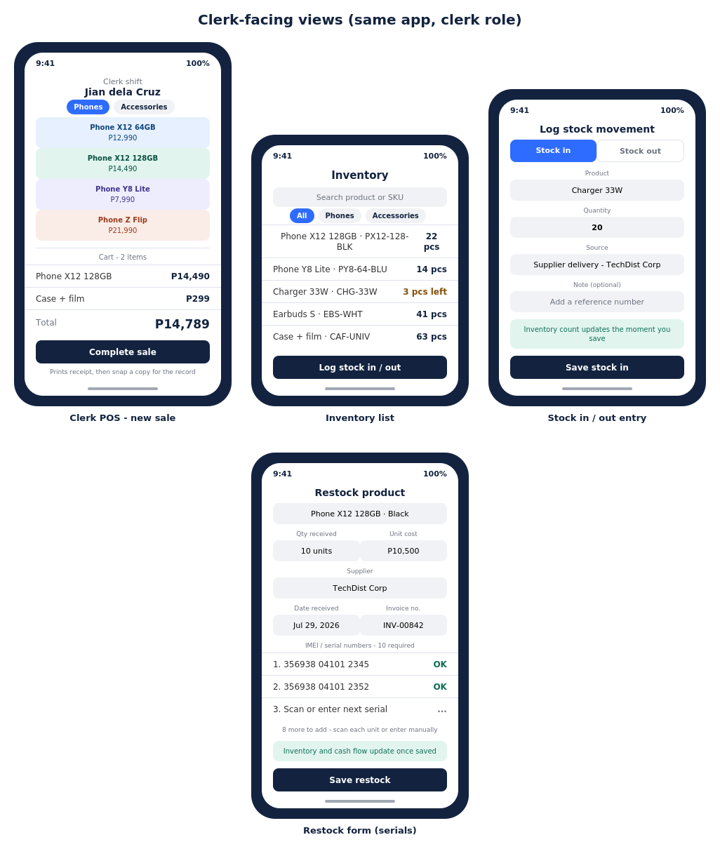

Owner-facing and public storefront views
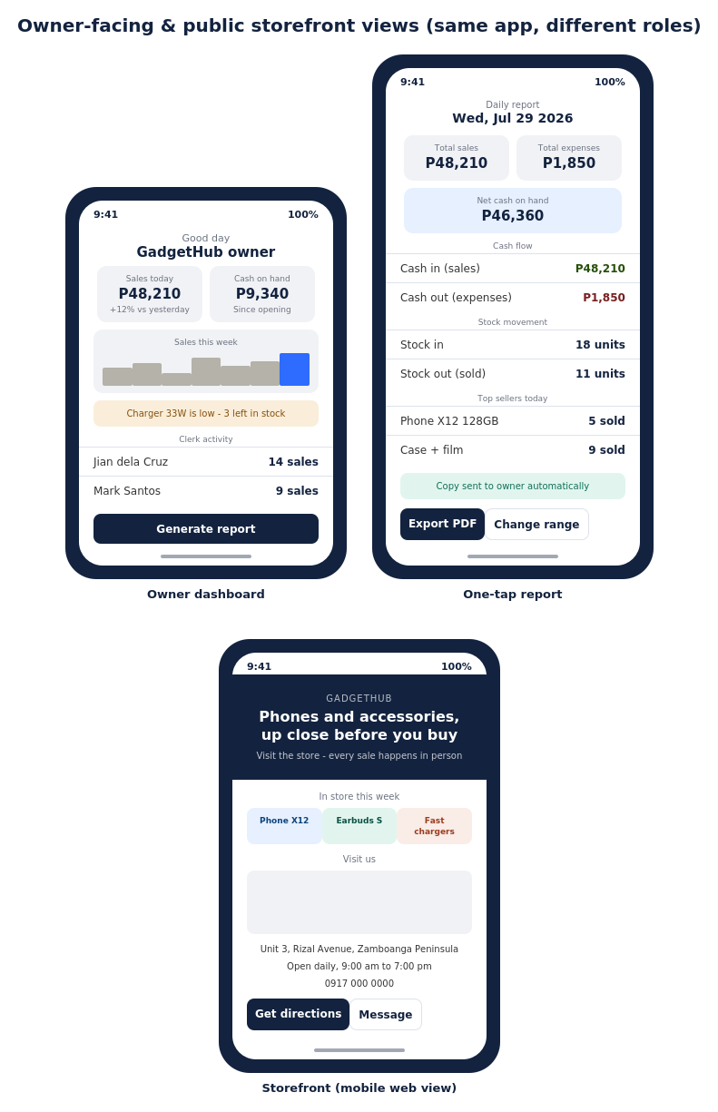
The same app, different login: live dashboard and one-tap reporting for the owner, and a public, view-only storefront for customers.



Storefront — web (desktop) view
The same public storefront, laid out for a wider screen — the PWA build deployed on Vercel.
